
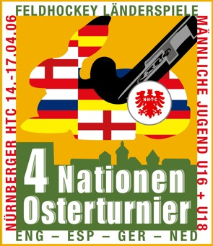
4-Nations Easter Tournament
U16 & U18 Boys
in Nürnberg

FEUILLE D’ENGAGEMENT |  |  |  | ENTRY FORM
COMPETITION:
DATES COMPETITION: | 14th – 17th April 2006 | PAYS / COUNTRY

JOUEURS – PLAYERS
Maillot  Shirt No.  1 – 32 | Nom de Famille  Family Name  [PRINTED – BLOCK LETTERS] | Prenom  First Name  [PRINTED - BLOCK LETTERS |  |  | Date of Birth  (dd/mm/yyyy) | Age | International Matches
Chef d’équipe/  Team Manager:  Chef en second/  Stand-in Manager: |  |  | Coach:  Médecin/Medical Doctor:  Physiothérapeute/  Physiotherapist:
COULEURS EQUIPMENT  TEAM COLOURS  Maillot/Shirt:  Jupe-Short/Skirt-Short:  Bas/Socks:  Maillot gardien/Goalkeeper shirt: |  |  | COULEURS DE REMPLACEMENT  ALTERNATIVE COLOURS  Maillot/Shirt  Jupe-Short/Skirt-Short:  Bas/Socks:  Maillot gardien/Goalkeeper shirt:
Un jeu doit comprendre au minimum 80% d'une même couleur par pièce
One set must comprise at least 80% single colour per piece
Goalkeeper shirt must comprise different colour to both primary and alternate colour of shirt
Nom/Name: |  |  |  | Date:
Position: |  |  |  | Signature:

